**Node Voltage Method**

**Objective of Lab:-**

1. Node Voltage Method.
2. Verifying Node Voltage Method.

* Mathematically.

**Node Voltage Method:-**

The node-voltage method allows for the calculation of the voltages at each node of the circuit, relative to a reference node. Once the node voltages are known, all currents in the circuit can be determined easily. The method leads to a set of simultaneous that must be solved. Bigger circuits will have more nodes and require more equations (more math).

**Steps of Node Voltage Method:-**

* Identify all of the nodes in the circuit.
* Choose one node to be the reference, usually called ground. Since voltage is a relative quantity (only voltage differences matter), we can choose one point in the circuit to be V = 0. The voltages at the other nodes will be with respect this ground node.
* Identify any other nodes for which the voltages (with respect to ground) are known.
* Look for other ways (like resistor reductions) that could be used to reduce the number of unknown voltages further. It is not necessary to calculate the voltage at every node.
* Assign currents to all of the branches connected to the nodes.
* Write KCL equations balancing the currents at each of the nodes.
* Use Ohm’s law to express resistor currents in terms of the (unknown) node voltages on either side of the resistor. (Be sure to get the correct polarity!)
* Substitute the resistor currents into the KCL equations to form the node-voltage equations. (Set of equations relating the unknown node voltages.)
* Do the math to solve the equations and determine the node voltages. Determine currents, powers, etc., if needed.

**Circuit Diagram:-**

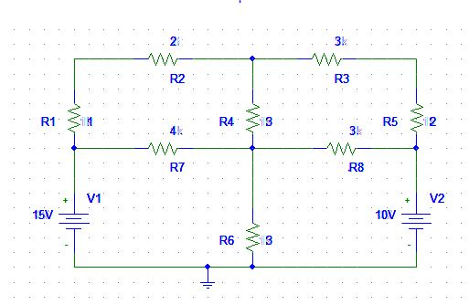

D

C

B

A

**Using Node Voltage Method:** As in above circuit diagram the voltage of node A and C are given A= 15V and C=10V. We only have to find the voltage of node B and D. For finding B and D we will follow the given steps.

**Node# b**

(b-a/3)+ (b-d/3) + (b-c/5) = 0

(0.33B -5) + (0.33b – 0.33d) + (0.2b-10)=0

**mesh# 02:**

1 I2 + 2 I2 + 3(I2- I1 ) + 3(I2 – I3)

1 I2 + 2 I2+ 3 I2 - 3 I1 + 3 I2 - 3 I3 **OBSERVATIONS**

9 I2 - 3 I1 - 3 I3 =0

**mesh# 03:**

3(I3- I2) + 4 I3 + 3 I3 + 1(I3 - I4)

3I3- 3I2 + 4 I3 + 3 I3 + 1I3 - 1I4

11I3 – 3 I2 - 1 I4 =0

**mesh# 04:**

2(I4- I1) +1(I4- I3) +2I4 =10

2I4- 2I1 +1I4- 1I3 +2I4

-1I3 + 2 I4 - 2I1 =-10

write in matrix form:

7 -3 0 -2 I1 15

-3 9 -3 0 I2 **=**0

0 -3 11 -1 I3  0

-2 0 -1 2 I4 -10

**result:**

I1 = 2.14a

I2 =748.30mA

I3 =102.04 mA I4 =1.122a

**ASSESSMENT RUBRICS LAB # 9**

**Node Voltage Analysis using PSPICE**

|  |  |  |  |  |
| --- | --- | --- | --- | --- |
| **LAB REPORT ASSESSMENT** | | | | |
| **Criteria** | **Excellent** | **Average** | **Nill** | **Marks Obtained** |
| 1. **Objectives of Lab** | All objectives of lab are properly covered  [Marks 0.5] | Objectives of lab are partially covered  [Marks 0.25] | Objectives of lab are not shown  [Marks 0] |  |
| 1. **Node Voltage Analysis**   **(Theory, Circuit Diagram )** | Brief introduction about Node Voltage Analysis (what is Node voltage analysis, What are nodes, How to apply KCL equations at each node) is shown along with properly labeled circuit diagram  [Marks 1] | Some of the points about Node Voltage Analysis are missing and circuit diagram is not properly labeled  [Marks 0.5] | Introduction about Node Voltage Analysis and circuit diagram is not shown  [Marks 0] |  |
| 1. **PSPICE**   **Simulator** | Brief introduction of PSPICE simulator  [Marks 1] | Brief introduction of PSPICE simulator  Is not shown  [Marks 0] | |  |
| 1. **Procedure** | All experimental steps are shown in detail along with how to verify Node Voltage Analysis.  [Marks 1.5] | Some of the experimental steps are missing  [Marks 1] | Experimental steps are missing  [Marks 0] |  |
| 1. **Observations & Calculations** | Mathematical calculations are shown and comparison with PSPICE results.  [Marks 5] | Mathematical calculations are shown but no comparison with PSPICE results  [Marks 2.5] | No mathematical calculations are shown  [Marks 0] |  |
| 1. **Conclusion** | Conclusion about experiment is shown  [Marks 1] | Conclusion about experiment is partially shown  [Marks 0.5] | Conclusion about experiment is not shown  [Marks 0] |  |
| Total Marks Obtained:__________  Instructor Signature: ______________________ | | | | |

**CIRCUIT SYSTEM-1**

**LAB # 9**



**Submitted By: Shah Raza**

**Registration# 18PWCSE1658**

**Section: “B”**

**Batch “20”**

**Submitted To: Engr.Muniba Ashfaq**